About the quality of location data in the EPER database

Preliminary results from a geocoding exercise on a rainy Sunday afternoon

Hermann Peifer, EEA, December 2008

Background and motivation

EPER, the European Pollutant Emission Register, is a public inventory on large and medium-sized industrial facilities, which contains data on the facilities' main pollutant emissions to air and water. During the second EPER reporting cycle (also known as EPER 2004), data have been collected and published for about 12000 facilities in EU25 Member States, Norway and Romania. The public EPER website with data search, download and visualisation services is hosted by EEA [0].

The EPER database contains location information, both in form of postal addresses and geographic coordinates of industrial facilities. This information can be useful, e.g. when studying possible effects of these industries on the health of neighbouring populations. However, as experience from EPER data usage [1] has shown: the quality of the location data in the EPER database varies considerably across countries and regions. Poor quality of EPER location data doesn't seem to be mentioned in official EPER review reports [2]. The issue is however known, e.g. an article published recently in the International Journal of Health Geographics discusses location data quality problems in Spain [3].

Given the above observations and considerations, my idea was to carry out a simple, if not simplistic quality check of EPER location data by calculating the distance between officially reported point coordinates and geocoded coordinates based on the reported addresses. The pre-condition for this approach is that reported addresses and coordinates refer to the same location, which they should, as the EPER decision requires that both pieces of information shall refer to the basic EPER reporting unit, which is the facility.

Geocoding: converting postal addresses into latitudes and longitudes
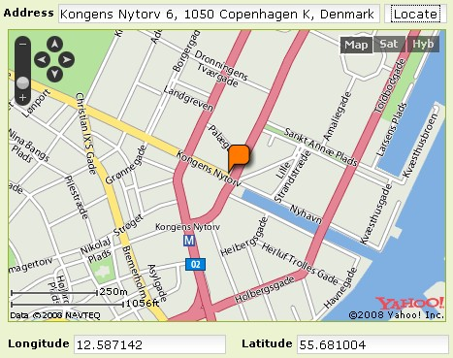
Geocoding [4] is the process of finding a latitude and longitude value for a given address. Google Maps, Microsoft Virtual Earth, Yahoo Maps and MapQuest are providing free and publicly available geocoding web services. One example of using such a service is the location functionality of EEA's events calendar, see screenshot and [5].

It might be obvious that manual geocoding in this way is not convenient for processing some 12000 EPER addresses. Luckily, some geocoders are also providing other means of accessing their services: they are accepting request URLs, where all query information is included in the URL itself.
These request URLs look like this:

http://BaseURL/Service/Method?address=<value>&zip=<value>&city=<value>&country=<value>

In order to use geocoding web services in the latter way, I downloaded EPER 2004 data in XML format from the public download page [6]. After converting the XML files (and the PDF document for Romania), I had addresses and coordinates for all 11923 EPER facilities in a flat text file.
Sending out geocoding requests in batch processing mode

The next step was to construct web service specific request URLs. These URLs look like the below examples, which are simplified for clarity reasons (e.g. the application or access key is missing).

http://maps.google.com/maps/geo?q=Kraftwerksstrasse+1,3435+Zwentendorf+an+der+Donau,Austria&gl=at&output=csv

http://local.yahooapis.com/MapsService/V1/geocode?location=Kraftwerksstrasse+1,3435+Zwentendorf+an+der+Donau,Austria

http://web.openapi.mapquest.com/oapi/transaction?address=Kraftwerksstrasse+1&city=Zwentendorf+an+der+Donau&country=AT&transaction=geocode

These URLs can be sent out conveniently in batch-processing mode, e.g. via a simple shell script. This script must foresee some delay between individual requests as too many or too rapid geocoding requests originating from the same host make the geocoder ignore any further queries. E.g. the daily limit for Yahoo Map API is 5000 queries per IP address, which means that it takes more than 2 days to process all 12000 EPER addresses.

There are a few other options for batch processing requests, e.g. one can send out requests via the website batchgeocode.com or use the Excel geocoding tool available at juiceanalytics.com [7]. These tools seem to be appropriate for limited batch processing exercises. However, I felt that with my own script, which was basically a shell one-liner, I had more control over request timing and response processing.

Receiving and evaluating the responses

After geocoding the address information, the geocoder will send a response back, typically in XML or plain text format, which might look as follows (again somewhat simplified).

Sample Google Map API response in csv format:
200,9,48.3447203,15.9103757 (status,GGeoAddressAccuracy,latitude,longitude)

Sample Yahoo Map API response in XML format:
<Result precision="city" warning="The exact location could not be found. Here is the center of the ZIP code.">
<Latitude>48.344745</Latitude>
<Longitude>15.910300</Longitude>
</Result>

Sample MapQuest OpenAPI response in XML format:
<location>
<latitude>48.344742</latitude>
<longitude>15.910300</longitude>
<geocodeQuality>CITY</geocodeQuality>
</location>

It is important to observe the quality of geocoding results. All 3 services used have some (more or less similar) result ranking terminology which goes from “No match” for the given address to very low quality (match on country level), medium quality (match on city name or post code) to high quality (exact address match). Obviously, geodocing results depend on both, the databases and geocoding techniques behind the web services, and the quality of the address information sent to them. In quite many cases, address values in the EPER database are completely empty, "-", "NA", "confidential" or simply inaccurate. Poor address data will always result in poor quality geocoding results. The GIGO law (Garbage In, Garbage Out) is in particular true in the area of geocoding.
Some initial results

Microsoft Virtual Earth: their geocoding services do not seem to have any option for directly sending request URLs as described above. There are hence no Virtual Earth geocoding results in the outcome of this limited exercise.

MapQuest: Geocoding results from their OpenAPI came all with CITY or only COUNTRY level quality. It is also stated on their website that their free services only provide geocoding of "postal codes and cities in many areas of the world" [8]. This level of precision is however not good enough in order to compare the results with reported coordinates from the EPER database.
I hence had to exclude MapQuest OpenAPI geocoding results from further processing.

Google [9] and Yahoo [10]: The combination of both services provides acceptable geocoding quality across Europe, with some significant differences by country. All Google and Yahoo geocoding results with city, zip, street and address accuracy are summarised in Table 1 below, see columns (3) to (6). Google has a higher share of exact address matches in Western Europe, but often fails in Eastern Europe. Yahoo has city and post code coverage for many countries in Eastern Europe, which is helpful in order to complement Google's geocoding results (see Annex for more details). The overall result is that 97% of all EPER facilities can be geocoded with a combination of both services.

------------------------------------------------------ ----------------
Ctry EPER | Geocoding results |Not suspicious|Suspicious
Code Facilities| Google Yahoo | Google&Yahoo| Num Pct |Num Pct
(1) (2) | (3) (4) | (5) (6) | (7) (8) | (9) (10)
-----------------------------------------------------------------------
AT 135 125 135 135 100% 114 84% 21 16%
BE 497 299 337 337 68% 315 93% 22 7%
CY 70 1 69 69 99% 23 33% 46 67%
CZ 339 277 307 339 100% 312 92% 27 8%
DE 1686 1403 1682 1685 100% 1546 92% 139 8%
DK 237 235 236 237 100% 234 99% 3 1%
EE 28 17 25 28 100% 25 89% 3 11%
ES 2159 800 2077 2122 98% 1459 69% 663 31%
FI 232 167 204 219 94% 169 77% 50 23%
FR 1770 930 1651 1728 98% 1510 87% 218 13%
GR 108 23 108 108 100% 56 52% 52 48%
HU 96 78 95 96 100% 84 88% 12 12%
IE 183 66 159 168 92% 130 77% 38 23%
IT 682 457 680 681 100% 591 87% 90 13%
LT 66 35 59 64 97% 32 50% 32 50%
LU 15 4 14 14 93% 14 100% 0 0%
LV 30 15 29 29 97% 23 79% 6 21%
MT 4 0 4 4 100% 4 100% 0 0%
NL 386 355 384 386 100% 361 94% 25 6%
NO 88 52 87 88 100% 77 88% 11 12%
PL 450 331 444 450 100% 291 65% 159 35%
PT 296 71 280 284 96% 237 83% 47 17%
RO 260 0 175 175 67% 73 42% 102 58%
SE 229 147 165 214 93% 141 66% 73 34%
SI 93 0 79 79 85% 69 87% 10 13%
SK 103 67 91 101 98% 92 91% 9 9%
UK 1681 716 1278 1675 100% 1147 68% 528 32%
-----------------------------------------------------------------------
Sum 11923 6671 10854 11515 97% 9129 80% 2386 20%
-----------------------------------------------------------------------

Table 1: Geocoding results, by geocoding service and country

Interpreting the results, or: What is suspicious?

As mentioned, the basic assumption for any further analysis is that reported address and reported coordinate refer to the same point, i.e. the location of the facility. The question is then how to interpret the distance between reported location and geocoded address. The following simple, if not simplistic methodology has been applied: distances above a given limit value are simply defined to be “suspicious”. The rule observes that geocoding results have different levels of precision:
Geocoding precision Distance is suspicious if
address > 1 km
street > 3 km
zip > 5 km
city > 10 km
The overall result for this approach shows that 80% of all EPER coordinates are relatively close to the geocoded addresses. These cases are all evaluated to be “not suspicious”, see columns (7) to (10) in Table 1. However, in the remaining 20% of the cases, the facility's location and the reported address are “suspiciously” far from each other. In this context, suspicious does not necessarily mean wrong. It is just an indication that further analysis is needed in order to make a judgement.

Results from some further analysis based on Google Earth viewing
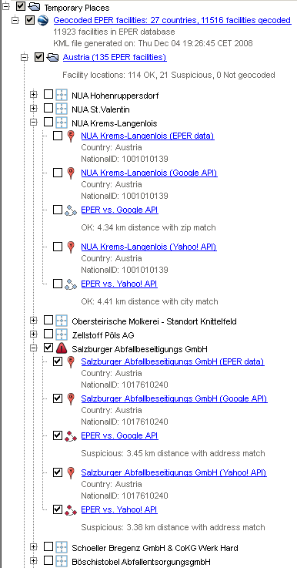
In order to carry out some further analysis, I converted the tabular results (i.e. reported and geocoded facility locations and the distances between them) into a KML file which can be loaded into Google Earth Viewer. The KML file presents all geocoded EPER facilities by country.
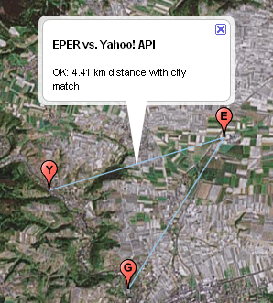
The point locations are visualised with small placemarks, where E represents the original EPER location, G and Y stand for geocoding results from Google and Yahoo. Points referring to the same facility are connected with lines. The evaluation results, i.e. suspicious and non-suspicious distances are shown using different icon and line styles, see the sample screenshots on this page.
Distance is
not suspicious
Distance is
suspicious
Some obvious patterns in EPER location data

a) Countries with a high share of geocoded addresses and a low share of suspicious distances

Facilities Suspicious Not geocoded
Austria 135 21 0
Czech Republic 339 27 0
Germany 1686 139 1
Denmark 237 3 0
Estonia 28 3 0
France 1770 218 42
Hungary 96 12 0
Italy 682 90 1
Luxembourg 15 0 1
Malta 4 0 0
Netherlands 386 25 0
Norway 88 11 0
Portugal 296 47 12
Slovakia 103 9 2

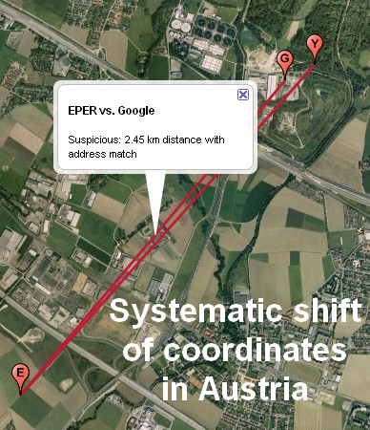
All countries above share the same characteristics: Google and Yahoo were able to geocode basically all facility addresses for these countries and their share of suspicious distances is low, i.e not substantially more than 10%. A spot check of Austria's 21 suspicious locations has shown that many of them look like a systematic shift of several kilometers, most likely due to a conversion error, see picture (1). It should be noted that 10% of suspicious locations can still mean hundreds of suspicious cases, e.g. for Germany or France.

(1)

b) Countries with obvious data quality issues

Spanish EPER facilities seem to fall all over the place: into Africa, Saudi Arabia and the Atlantic Ocean. There seem to be systematic and less sytematic data quality issues. E.g. a longitude value of -3.7 is reported to be
at -37 (picture 2).

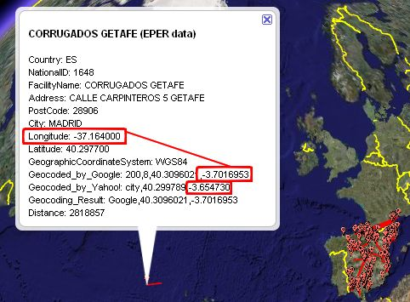
Another systematic problem with Spanish location data is that many facilities from the Spanish Basque region are actually located around longitude 2...3° West, however, in the EPER database, their longitude values are around 2...3°East, which makes these facilities fall into France, see picture (3) below.
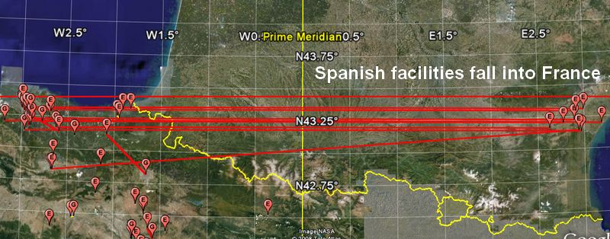
(2)
(3)
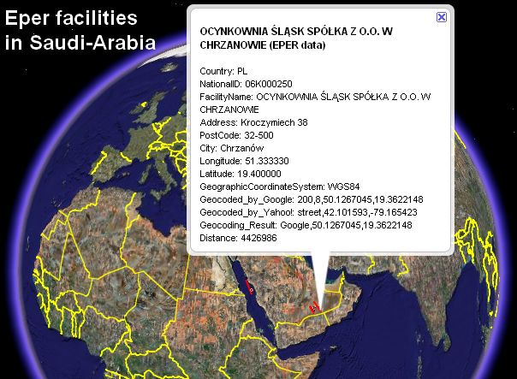
Some Polish facilities fall near Sweden, others seem
to be located in Saudi Arabia. The latter phenomenon is an obvious swap of longitude and latitude values.
A typical Polish facility location would be at 20E, 50N, the swapped values turn out to fall at 50E, 20N, i.e. somewhere in Southern Saudi Arabia (picture 4).

c) Some observations for other countries
(4)
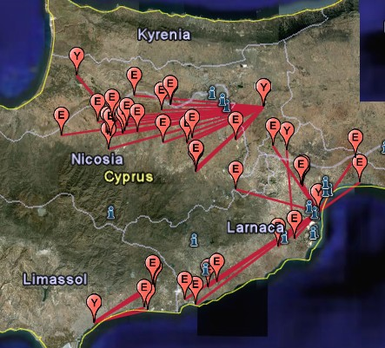
Belgium EPER data contains confidential addresses that could not be geocoded. However, the remaining location data seems to be of reasonable quality, as distances between geocoded addresses and EPER coordinates are “not suspicious” in 93% of the cases.

Cyprus has many “suspicious” locations, but this seems to be more a weakness of my simple approach rather than an EPER data quality issue: The geocoder cannot resolve the somewhat vague address information from Cyprus, but finds a matching city name (e.g. Nicosia, Larnaca or Limassol). As the (apparently correct) EPER location is far away from the geocoded city centre point: the evaluation of the distance results into “suspicious”. However, all these cases seem to be “false positive” results (picture 5).
(5)

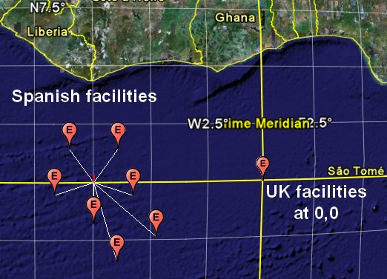
Romania: the share of geocoded addresses is rather low. On the other hand, addresses that have been geocoded are often suspiciously far away from the reported location. I have not done any further checking. Poor address coverage for Romania in Google and Yahoo geocoding services might be a limitation. It also has to be taken into account that the Romanian data were converted from a different data source, i.e. from a PDF document (their voluntary EPER delivery was not provided in the usual XML data format).
(6)
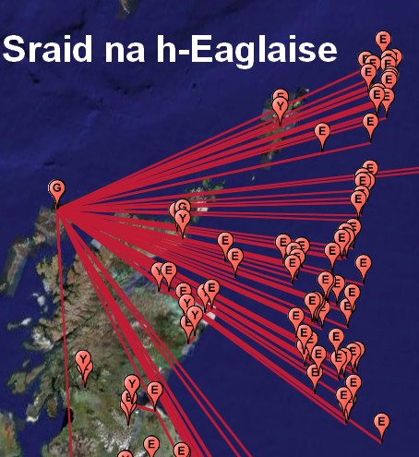
Many UK EPER facilities have confidential addresses. Coordinate values for these facilities are are simply set to 0,0 (picture 6). Confidential addresses and dummy values are obviously not a good starting point for any geocoding exercise.
(6)

The UK's offshore oil rigs in the North Sea resulted into a surprising geocoded location. The values sent to the geocoder were: address=”NA” and country=”UK”.
Yahoo couldn't find any concrete place based on this fragmentary piece of information and only returned the UK's center point, i.e. a geocoding result with country level precision. Google's geocoder was obviously, say, over-motivated, went further and found a street level match for all platforms: Sraid na h-Eaglaise, a road name on the Scottish Isles of Lewis (7). The distances between EPER locations and wrong geocoding results (several 100 km) look suspicious according to the simple evaluation rules. However, what is really suspicious: the geocoder's string comparison logic.
(7)
(7)
Summary for executives

Geocoding is the process of finding a geographic coordinate for a given address. Among others, Google, MS Virtual Earth, Yahoo and MapQuest are providing free geocoding web services.
The EPER data contains addresses and coordinates for around 12000 facilities in 27 EEA countries. When comparing reported facility point coordinates with geocoding results from Google and Yahoo, the overall result is that in 20% of the cases, reported location and address are “suspiciously” far from each other. A spot-check of suspicious cases shows obvious data quality issues for some countries, but also reveals some weaknesses of the simplistic screening approach.

Where to go from here

As mentioned in the title of this document, the described geocoding exercise and the presented results are a product of single rainy Sunday afternoon (to be honest: it took a bit more ;-)

Potential usage of the results:
- The exercise could be re-run, with updated data and a somewhat refined methodology. Results could then be sent back to data providers, in good time before the next EPER
(now called: E-PRTR) data collection in June 2009 [11].
- We could consider a generic Reportnet Automatic QA module that would compare reported locations with coordinates derived from geocoding. This module could be integrated into any data flow where both addresses and point coordinates are provided. It could complement our current country bounding box test for point coordinates, which has its own weaknesses but can always be used if no address information is provided.

If you are interested and want to know more details, have questions or some constructive comments: you are more than welcome to contact the author: hermann.peifer@eea.europa.eu

Some references

[0] EPER website at EEA: http://eper.eea.europa.eu/eper/

[1] For EPER data usage, see e.g. this Google Earth Community posting:
http://bbs.keyhole.com/ubb/showflat.php?Number=1095022

[2] For EPER review reports, see: http://eper.eea.europa.eu/eper/EPERReview.asp

[3] Validation of the geographic position of EPER-Spain industries, see:
http://www.ij-healthgeographics.com/content/7/1/1

[4] Wikipedia, the free encyclopedia: http://en.wikipedia.org/wiki/Geocoding

[5] Event Location: Use the address to retrieve the location
http://www.eea.europa.eu/events/submitted/createQuickEvent

[6] Home > Download > EPER data, see: http://eper.ec.europa.eu/eper/extract_data.asp

[7] http://www.batchgeocode.com , http://www.juiceanalytics.com/writing/excel-geocoding-tool-v2/

[8] MapQuest Platform Services, see: http://platform.mapquest.com/specs-free.html

[9] Google Map API services, see http://code.google.com/apis/maps/documentation/services.html

[10] Yahoo! REST API, see: http://developer.yahoo.com/maps/rest/V1/

[11] E-PRTR reporting obligation in ROD: http://rod.eionet.europa.eu/obligations/538

Annex I: Detailed geocoding results from Google Map API and Yahoo Map API
------------------------------------------------------------
Ctry EPER | Geocoding results from Google (in %)
Code Facilities| address street zip city ctry/NA
------------------------------------------------------------
AT 135 81 7 3 1 7
BE 497 34 25 0 0 40
CY 70 0 0 0 1 99
CZ 339 35 34 5 8 18
DE 1686 58 22 1 1 17
DK 237 88 11 0 0 1
EE 28 36 25 0 0 39
ES 2159 11 26 0 0 63
FI 232 38 27 3 3 28
FR 1770 12 37 0 3 47
GR 108 2 3 3 14 79
HU 96 49 31 1 0 19
IE 183 1 11 0 24 64
IT 682 21 46 0 0 33
LT 66 39 12 0 2 47
LU 15 0 27 0 0 73
LV 30 37 13 0 0 50
MT 4 0 0 0 0 100
NL 386 83 8 0 0 8
NO 88 38 22 0 0 41
PL 450 49 22 0 3 26
PT 296 2 20 0 1 76
RO 260 0 0 0 0 100
SE 229 41 18 1 3 36
SI 93 0 0 0 0 100
SK 103 10 41 15 0 35
UK 1681 1 38 2 1 57
-----------------------------------------------------------

------------------------------------------------------------
Ctry EPER | Geocoding results from Yahoo (in %)
Code Facilities| address street zip city ctry/NA
------------------------------------------------------------
AT 135 23 4 14 59 0
BE 497 33 7 3 25 32
CY 70 0 0 30 69 1
CZ 339 1 3 17 70 9
DE 1686 28 4 4 64 0
DK 237 45 3 5 47 0
EE 28 7 7 18 57 11
ES 2159 3 8 9 76 4
FI 232 14 3 34 37 12
FR 1770 5 9 11 68 7
GR 108 3 1 28 69 0
HU 96 0 0 34 65 1
IE 183 0 0 85 2 13
IT 682 13 14 5 68 0
LT 66 0 0 73 17 11
LU 15 7 7 80 0 7
LV 30 0 0 27 70 3
MT 4 0 0 75 25 0
NL 386 67 4 21 8 1
NO 88 5 1 7 86 1
PL 450 16 11 54 18 1
PT 296 4 1 40 49 5
RO 260 0 0 67 0 33
SE 229 5 7 34 26 28
SI 93 0 2 33 49 15
SK 103 1 5 20 62 12
UK 1681 2 16 10 48 24

Annex II: calculating distance
# Script to calculate the distance between two longitude/latitude points
# It calculates great-circle distances between the two points, i.e. the
# shortest distance over the earth's surface using the Haversine formula.
# It assumes a spherical earth, ignoring ellipsoidal effects,
# which is accurate enough for most purposes.
# see: http://mathforum.org/library/drmath/view/51879.html
#
# Hermann, November 2008

BEGIN {
# Definition of pi
pi = atan2(0, -1)

# The earth's mean radius
a = 6378137 # Equatorial radius (in m)
b = 6356752 # Polar radius (in m)
r = (a + b) / 2 # ~ 6367 km

# Translate Google's GGeoAddressAccuracy levels into Yahoo! precision names
precision[0] = "unknown"
precision[1] = "country"
precision[2] = "state"
precision[3] = "state"
precision[4] = "city"
precision[5] = "zip"
precision[6] = "street"
precision[7] = "street"
precision[8] = "address"
precision[9] = "address"

# Limits for suspicious distances, depending on geocoding precision
limit["city"] = 10000
limit["zip"] = 5000
limit["street"] = 3000
limit["address"]= 1000
}

# Great circle distance, using the Haversine formula
# Input: 2 coordinates in decimal degress: "longitude,latitude,precision_level"
function distance(p1,p2,p, A,B,lon1,lat1,lon2,lat2,dlon,dlat,a,c,d) {

# Split the input values
split(p1, A, ",")
split(p2, B, ",")

# Convert degrees to radians
lon1 = A[1] * pi / 180
lat1 = A[2] * pi / 180

lon2 = B[1] * pi / 180
lat2 = B[2] * pi / 180

dlon = lon2 - lon1
dlat = lat2 - lat1

# Calculate the distance
a = sin(dlat/2)^2 + cos(lat1) * cos(lat2) * sin(dlon/2)^2
c = 2 * atan2(sqrt(a), sqrt(1-a))
d = r * c

# Distance rounded to nearest 10 m
d = sprintf("%.0f0", d/10) + 0

return d OFS p OFS (d > limit[p] ? "Suspicious" : "OK")
}

